**WEEK 2**

**Hands_on Exercises on Logging using SLF4J**

Exercise 1: Logging Error Messages and Warning Levels Task: Write a Java application that demonstrates logging error messages and warning levels using SLF4J.

->

Step1: 1. Adding SLF4J and Logback dependencies to your `pom.xml` file.

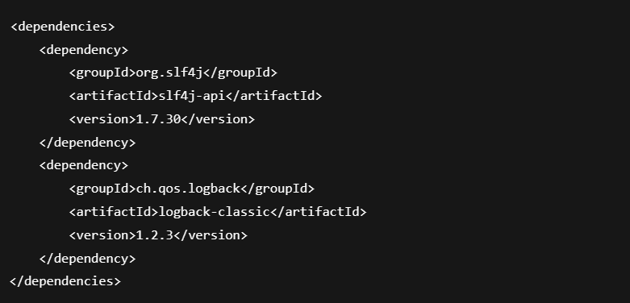

Step 2: Create a Java class that uses SLF4J for logging:

-> 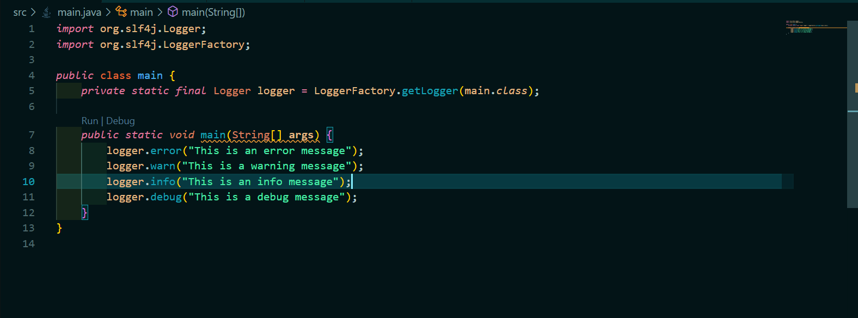

OUTPUT

